BASIC FUNTIONALITY

In information technology, functionality (from Latin functio meaning "to perform") is the sum or any aspect of what a product, such as a software application or computing device, can do for a user.

A product's functionality is used by marketers to identify product features and enables a user to have a set of capabilities. Functionality may or may not be easy to use.

Qtn.

In the ATC definition, what could be the capabilities which were considered when sourcing for a Rms solution?

**Web service orchestration**

Web service orchestration is the direction of specific web service business processes by a central controller. The controller, which can also be a Web service, coordinates asynchronous interactions, flow control, business transaction management and business process monitoring. Business process modeling notation (BPMN) is used to define a visual representation of the flow and business process execution language (BPEL) is used to write the code that executes the services.

● **Corona TR7z k2 and TR7Z Triton 5 architecture**

Introduction of architecture

Architecture is both the process and the product of planning, designing, and constructing Hardware, systems and associated structures

1. Communication-information(alarms + data) -presentation and reports and storage

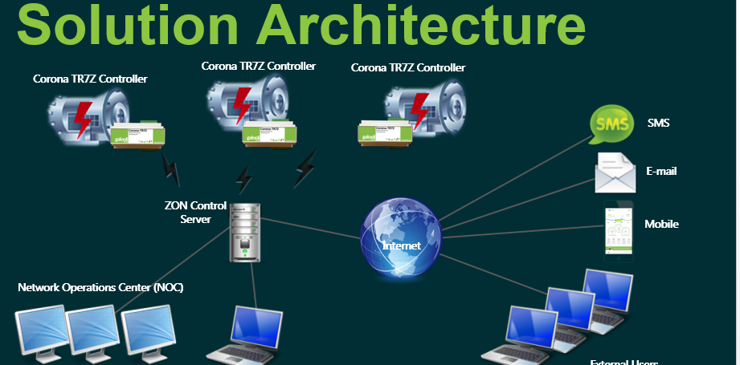

**Process** definition, a systematic series of actions directed to some end, (communication).

**A product** is the item offered for sale, it can be a service or an item, it can physical, virtual or cyber form,(information).

**Design** definition is - to create, fashion, execute, or construct according to plan,(data and reports)

**Construction** definition is - the act or result of construing, interpreting, or explaining,(stored data and historical data)

Communication is tied to actions initiated by devices eg relays-product- signals to the corona ( information)-and to the server- design filters and sends to the user appropriate customized status reports to the user.

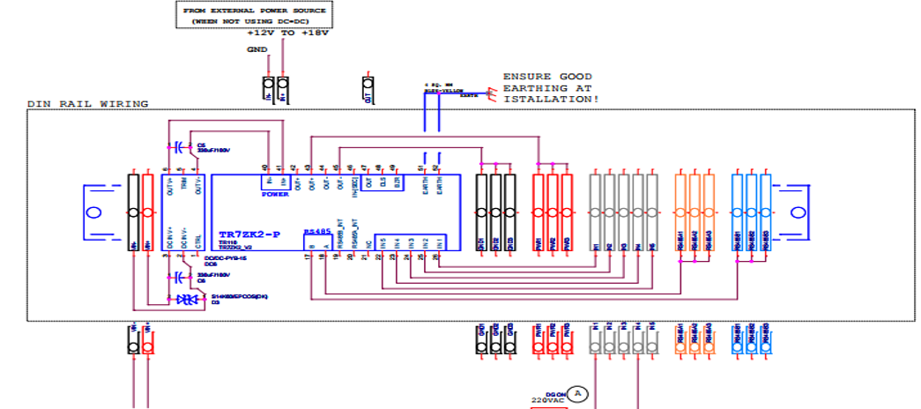

**The corona has**

**Kit;**

Which connects devices from the site hardware to the card through a regulated controlled circuit.

The Kit receives the signals as from the card and with the help of the gsm simcard communicates this information to the server.

The unit is powered by an external power supply and an internal back up battery which keeps the unit alive when external power fails.

The unit keeps in connection with network internet by the help of the Gsm antenna.

The unit is also equipped with a gps antenna which keeps its location defined through the satellite definitions.

Connector bridge is fitted so the wired inputs are kept firm to the unit board connections.

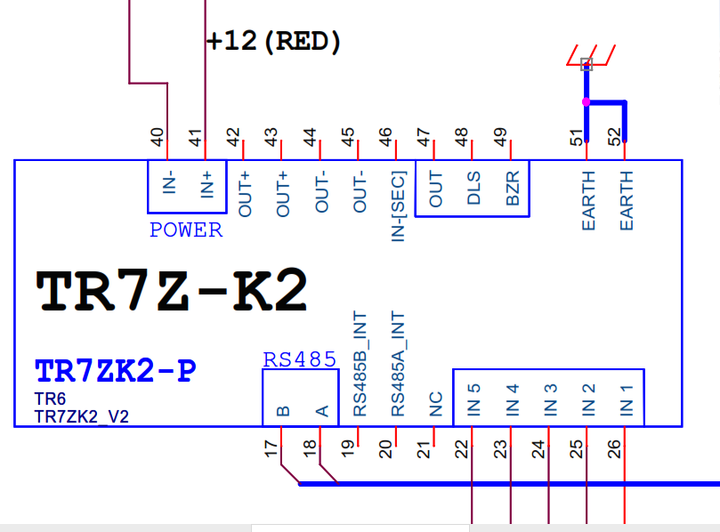

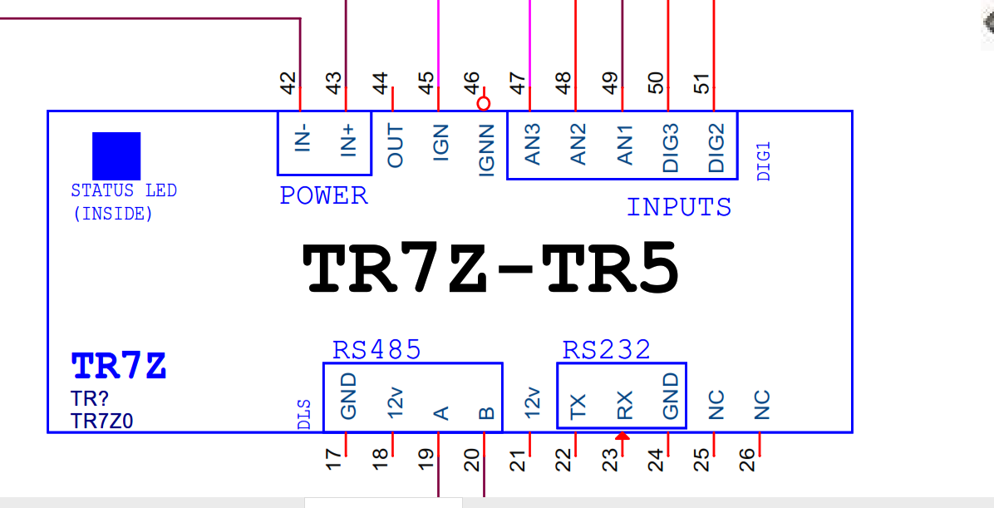

The triton 5 unit has similar functionalities like the K2 but has a few limitations.

Ability to process a large amount of data packets from multiple integratable devices

Two provisions of antenna gsm and gps extended out of the unit box.

● **Normal Operational Status.**

Products and Services, including our current status and uptime information.

Operational status can be define

1. Visual inspection
2. Powering in recommended environments as per the manufacturer specifications
3. Connecting to an external diagnostic device example a computer.

For desired results to be achieved the unit must be powered, power source is 12 VDC source**.**

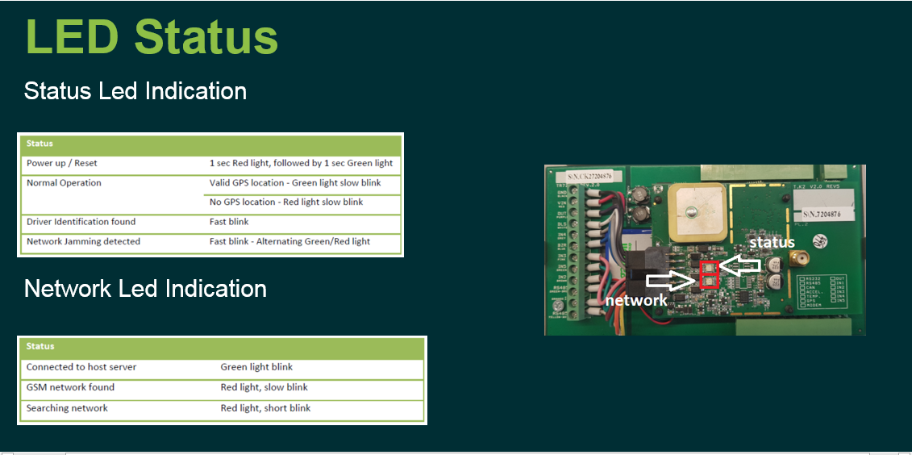

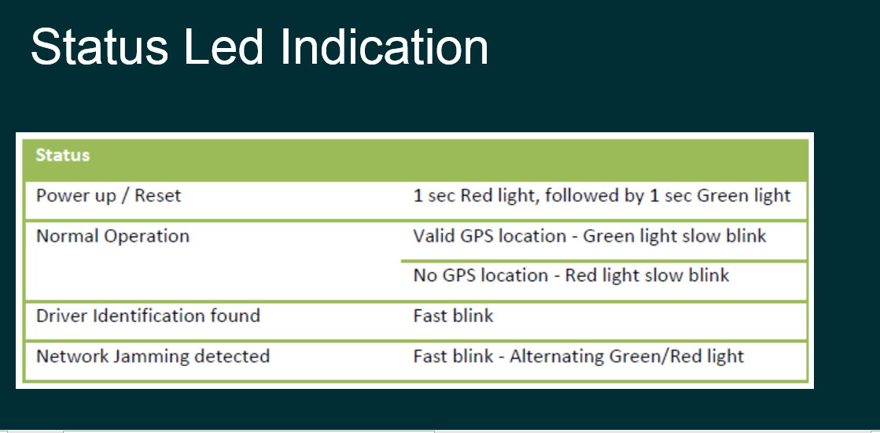

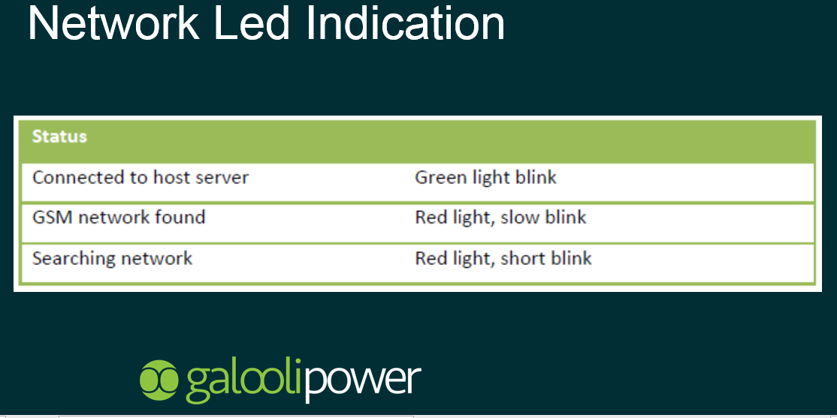

**● Configuration**

Relative arrangement of parts or elements.

Connection to power source-powering with recommended voltage, establishing serial connection with a computer, upgrading the device, uploading configurations of devices.

Viewing the communication status of the configured and connected devices.

● Device Firmware versions and software upgrades

● Operation & Maintenance

Maintenance involves operational and functional checks, servicing, repairing or replacing of necessary devices

Back up battery.

Disconnections – investigated and resolved.

Faulty devices will call for replacements.

Preventive maintenance will include –Software upgrades, routine checks on joints and terminations.

Protection will include grounding of the device

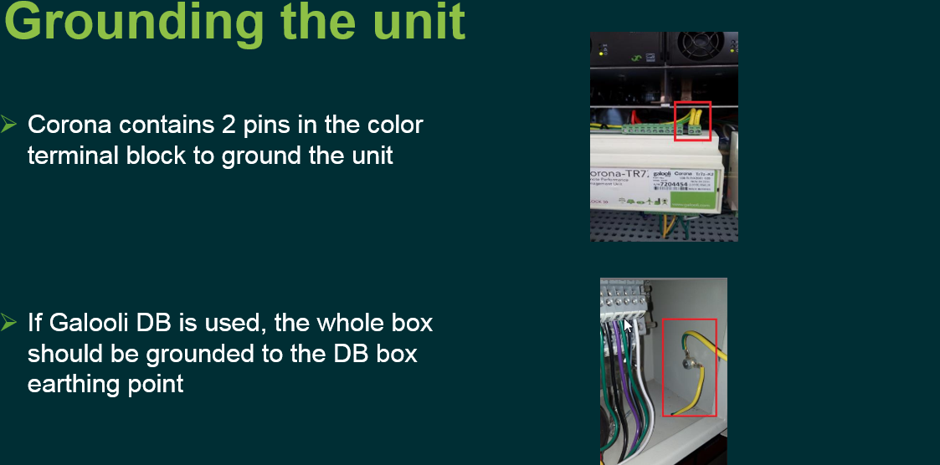

Check and trouble shoot simcard in case of gsm ( signal related disconnections)

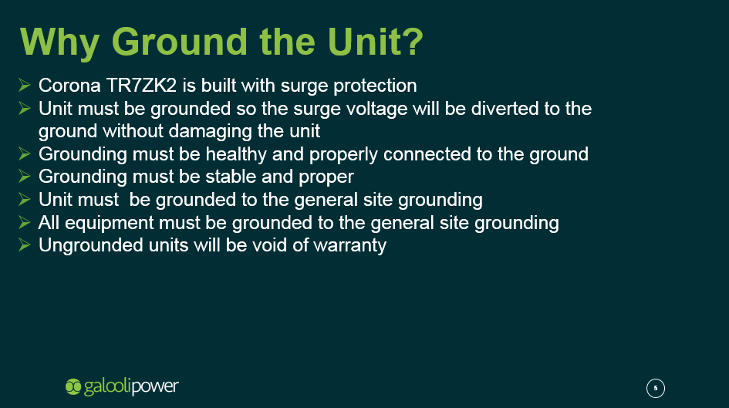

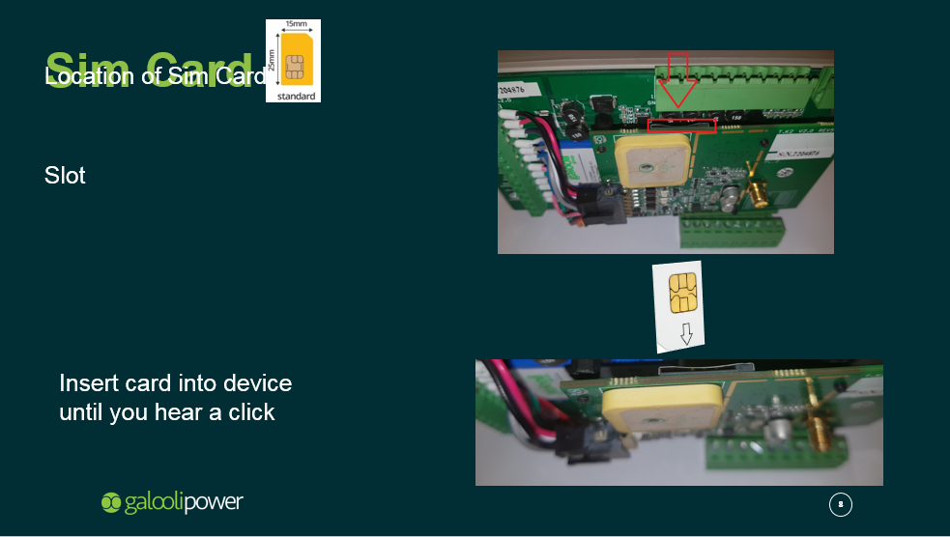

Wiring diagrams, calibration tubes, configuration cables, fuel tape measure.